Dallie Shell
Contemporary Social Welfare Policies
Professor Eversman
April 18, 2018
“Misguided drug laws and draconian sentencing
have produced profoundly unequal outcomes for communities of color” (Alliance).

The notion that slavery and the laws that govern the institution of free labor has been replaced by incarceration, and social policies that are perceived by minorities in society as “New Jim Crow Laws” (Alexander, 2012). Jim Crow laws are historically biased, and These are laws that are racially biased, and is supposed to be geared towards addressing crime. But is racially targets and its relation to drugs, but mainly apply to one race, or people of a certain ethnicity, thus making these laws a tool used to maintain institutional oppression. Therefore, the social policy that is believed to be a contributing factor to mass incarceration, while acting as an expediting agent of criminalization, and was supposed to address the problem that crack cocaine created in society is the Anti-Drug Abuse Act of 1986. Therefore, this section addresses the social policy, and issue.
Mass incarceration is the leading cause of racial exclusion, because although the United States boasts the highest incarcerated population, what doesn’t get boasted is the fact that in “2002 about twelve percent of African American men between ages twenty, and thirty-four years old were behind bars” (Howard Jacob Karger, 2013). This social welfare issue affects the colored population, especially men within the United States, by systematically forcing them in the judicial system, utilizing biased tactics to conduct police work, and conducting these “operations primarily in poor communities of color “ (Alexander, 2012). Furthermore, upon release ex-offenders are sanctioned by law, thus disqualifying them from utilizing the federally funded programs that is conducive to helping previously incarcerated offenders desist from crime, Moreover, this prevents the previously incarcerated from competing in the workforce, while influencing them to make decisions based on survival, instead of rationality.
This issue socially affects African Americans, because it develops a underclass that is referred to as a “New caste system of legally classified second class citizens” (Alexander, 2012), and as a result of this, the previously incarcerated individuals are denied help from agencies, and programs that are geared towards preventing hunger, and homelessness. Therefore, leaving a person who was previously released to make all their decisions based on survival, instead of reasoning; this ultimately influences them to continue indulging in criminal attitudes, and behaviors. This form of extreme decision making can lead to substance use/abuse as a way to cope, and usually leads ex-offenders to reoffend, thus emulating the revolving door ideology of the judicial system.
Arguably, illicit drugs have been an ongoing problem in the United States of America, and were nationally recognized, because of the damage, social dysfunction, and increase in crime that the substance was causing in American society. This is what initially prompted the “former President Nixon to create and implement “the controlled substances act in to law in 1970” (Alliance E. O.), to combat the issue that American society was experiencing with drugs, while prompting congress to implement stiffer drug policies in hopes of deterring people from using, dealing, and or trafficking the substance. Although there were plenty of laws passed that were geared towards addressing the above mentioned social issue, this section discusses the historical review “anti-drug abuse act that President Ronald Reagan signed into law on October 27, 1986.” (Vagins and McCurdy, 2006).
During the year 1986, when crack was wreaking havoc on inner cities, and neighborhoods in suburbia. The American government was already in the process of concocting a policy that would aggressively address the social issue that they were experiencing. However, it wasn’t until the untimely demise of Len Bias who was a professional athlete that died hours after being drafted by the Boston Celtics, and “sparked a national media frenzy largely focused on the drug that was suspected, mistakenly, of killing him – crack cocaine” (Vagins and McCurdy, 2006) that fueled the immediate enactment of the anti-drug abuse act of 1986. But with the continued media portrayal of violent crimes being linked to the use of crack cocaine, it enhanced the growing fear of the crack epidemic that was emanating, influenced the Nixon administration to adopt “The Anti-Drug Abuse Act of 1988, that established the policy goal of a drug free America, as well as the office of National Drug Control Policy” (Byrnes)
Moreover, the Anti-Drug-Abuse Act of 1986, is a federal policy that severely punishes people who are apprehended for the distribution of crack cocaine substantially more than distributing powder cocaine, because it mandates a term for “distribution of just 5 grams of crack to a minimum 5-year federal prison sentence, while for powder cocaine, distribution of 500 grams – 100 times the amount of crack cocaine – carries the same sentence” (Vagins and McCurdy, 2006). This policy established for the first time; sentences that required individuals to serve a mandatory minimum for drug distribution. This form of sentencing is initiated by being proven guilty of possessing, distributing, or trafficking “specific quantities of cocaine” (Vagins and McCurdy, 2006).
Therefore, this policy should have addressed the drug issue, but instead recreated the already looming societal drug problem, and ignited another social issue that plagues colored people. But judging by the stiff sentencing guidelines governing the anti-drug abuse act, society viewed people who used, sold, or trafficked drugs as dangerous criminals who should be incarcerated to address the problem. This is because of political hysteria, and the deeply embedded core societal values of racial biases. We see this value of racial bias expressed in the policy by the number of colored people who are incarcerated, and the fact that this policy is causing a shortage of successful black men in society, while keeping them confined at an alarming rate in prisons, county jails, and on supervision.
This is why some may say or assume that the Anti-Drug Abuse Act of 1986 and 1988 was part of a plot that guaranteed growth in the prison population, which in turn produced economic opportunities for investors, philanthropists, and members of the government for investing in privatized prisons. Therefore, people assume that this is sort of like a top down approach, because the policy targets people who possess, distribute, and traffic the substance in powder or crack cocaine form. But it does not offer or mandate the chemically addicted offenders to get help addressing the issues they may be having with substance use, and abuse to address the drug epidemic that was causing total carnage on society. This epidemic of substance uses and abuse initiated a wide spread scare amongst Americans in the United States, which was largely due to the “media portrayals of people addicted to the smoke able form of cocaine dubbed crack” (A Brief History). Therefore, this section focuses on values, stake holders, and political discourse.
The social work ethical principle that best reflects how professional social work believes substance abuse, and mass incarceration should be addressed is first we have to “respect the inherent dignity and worth of the person.” (National Association), because “social workers seek to enhance client’s capacity and opportunity to change and to address their own needs” (National Association), thus emphasizing the importance of a healthy working relationship between the helper and the client in order to begin to address the potential issues they are facing as a result of combating the social dysfunction that was caused by the illicit substance called “Crack Cocaine”. But these ethical social work principles are inconsistent with the policy, because the Anti-Drug Abuse policy emphasizes the need of incarceration for the possession, distribution, and trafficking of cocaine. Whereas the ethical social work principle emphasizes the need to “respect the inherent dignity and worth of the person.” (National Association), because “social workers seek to enhance client’s capacity and opportunity to change and to address their own needs” (National Association), this examines the possible need to educate offenders in order to help them become self-reliant, while remaining drug use, and crime free.
The implementation of policies like the Anti-Drug Abuse Act of 1986, and 1988 were influenced by people who are all members of the “American Legislative Exchange Council (ALEC), which demonstrates the classic connections between politics, economics, and the criminal justice system” (Randall G., 2011). This organization consists of “private corporation executives, criminal justice officials, and more than one-third of state lawmakers in the country” (Randall G., 2011) But one of the leading stake holders, and largest private prison corporation is an organization called Corrections Corporation of Americana. Therefore, legitimizing the notion those policies governing criminalization and incarceration focuses more on financial gain, then it does on correcting behaviors. Thus signaling the political discourse of what policies like the Anti-Drug Abuse Act of 1986 and 1988 should do, as opposed to what it actually does.
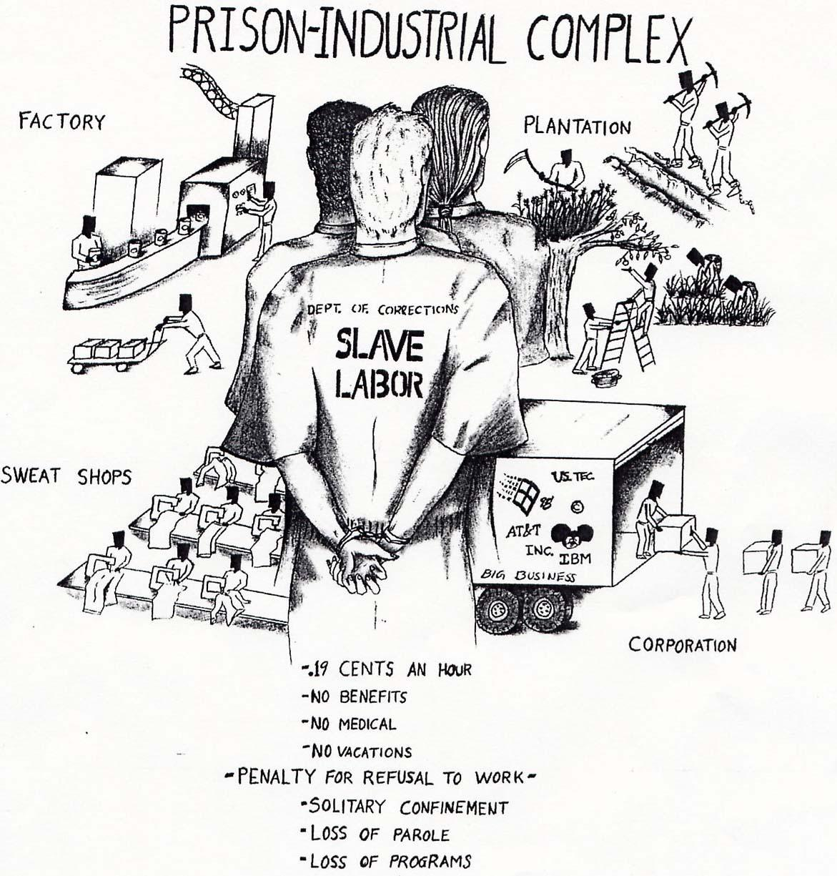

Furthermore, the political discourse that is being referred to here is racism, institutional oppression, and political gain. This is demonstrated by the politicians who established what is known in New Jersey as the Department of Corrections, and the prisons are referred to as correctional facilities. These facilities should specialize in correcting criminal attitudes and behaviors of inmate who are serving a term of incarceration as a form of punishment for breaking the law, and to deter the continuance of criminal behavioral attributes. But these facilities horribly fail to offer realistic rehabilitative programs to assist the inmate in their journey to shift their paradigm. This adversely diminishes the possibility of people who are incarcerated to rehabilitate themselves, and suggests that incarceration is not about deterrence, public safety, or the constitution; it’s about replacing the face of slavery with incarceration in an effort to recreate slavery in a more acceptable and justified perspective.
In concluding, the Anti-Drug Abuse act of 1986, and 1988 have religiously contributed to the generated wealth, and political corruption surrounding incarceration. Because it reaffirms the notion that incarceration is not about correcting the behavior of criminals at all. It’s about disrupting the black family structure, by forcing men, women, and children in to poverty. This type of atmosphere forces people to reject rational, and embrace criminality. The type of decisions that one will not understand unless they have experienced those issues and situations themselves. These policies guarantee that prison beds will be filled, and the poverty stricken neighborhoods where black and Hispanic people are the targets, this is the communities that it effects the most. Because the correctional facilities that house the minorities that are serving a mandatory minimum sentence, fail miserably to offer realistic rehabilitative programs to the inmate population. Therefore, creating the revolving door effect of incarceration, while insinuating that society needs stiffer drug laws, and how current policy is not working. This is correct, the Anti-Drug Abuse Act of 1986, and 1988 do mandate rehabilitation, and it is not working…. Properly!

References
A Brief History Of The Drug War. (n.d.). Retrieved from Drug policy.org
http//www.drugpolicy.org/brief-history-drug-war
Alexander, M. (2012). The new jim crow. New York: The New Press.
Alliance, E. a. (n.d.). Race and the Drug war. Retrieved 2018, from Drug Policy Alliance: http://www.drugpolicy.org/issues/race-and -drug-war
Alliance, E. O. (n.d.). A brief history of the drug war. Retrieved from Drug Policy.org: www.drugpolicy.org/issues/brief history drug war
Byrnes, F. (n.d.). Article Doctor. Retrieved from Article Doctor: www.articledoctor.com/drugabuse/anti-drug-abuse-act-of-1988-897
Deborah J. V. & Jesselyn M. (2006) Cracks in The System. Twenty Years Of The Unjust Federal Crack Cocaine Law, Washington D.C. : American Civil Liberties Union
Foner, E. (1990). A short history of Reconstruction, 1863-1877. New York: Harper & Row.
H., E. D. (2017). Essentials of Human Behavior. Sage Publications INC.
Howard Jacob Karger, D. S. (2013). American Social Welfare Policy. Upper Saddle River: Pearson.
Julie B., M. B. (n.d.). The Practice Of Generalist Social W.
National Association of Social Workers, Social Work Code Of Ethics
https://www.socialworkers.org/About/Ethics/Code-of-Ethics/code- of- Ethics English

Ore, T. E. (2011). The Social Construction Of Difference & inequality. New York: McGraw-Hill Education.
Randall G., S. P. (2011). Interest groups and Criminal Justice Policy. Retrieved from Center On Juvenile &
Criminal Justice:www.cjcj.org/uploads/cjcj/documents/interest_group_and_criminal_justice_policy pdf

staff, H. (2009). Thirteenth Amendment. Retrieved 12 16, 2017, from History.com: http://www.history.com/topics/black-history/thirteenth-amendment
http://www.prisonabolition.org/what-is-the-prison-industrial-complex/political discourse=image

